**Assignment 1**

**Q1. Environment Setup:**

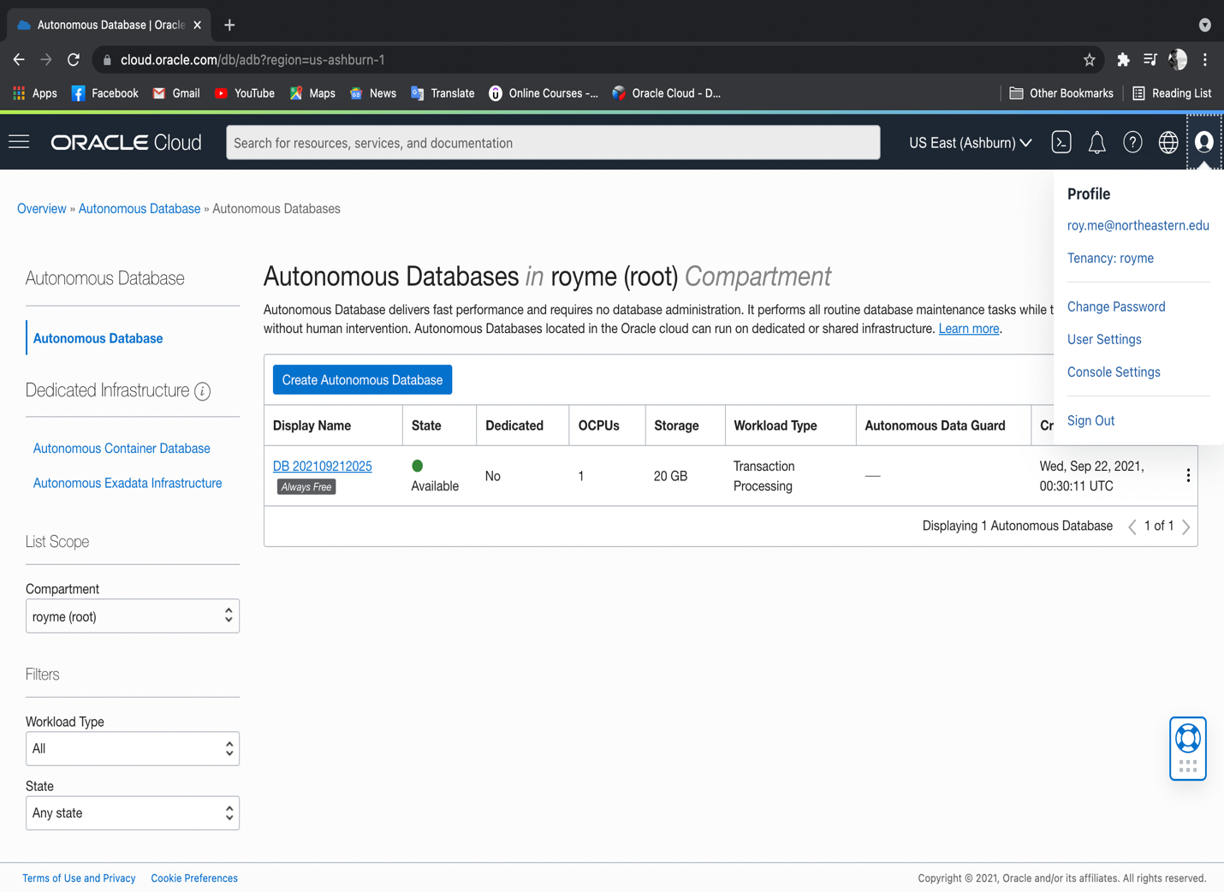

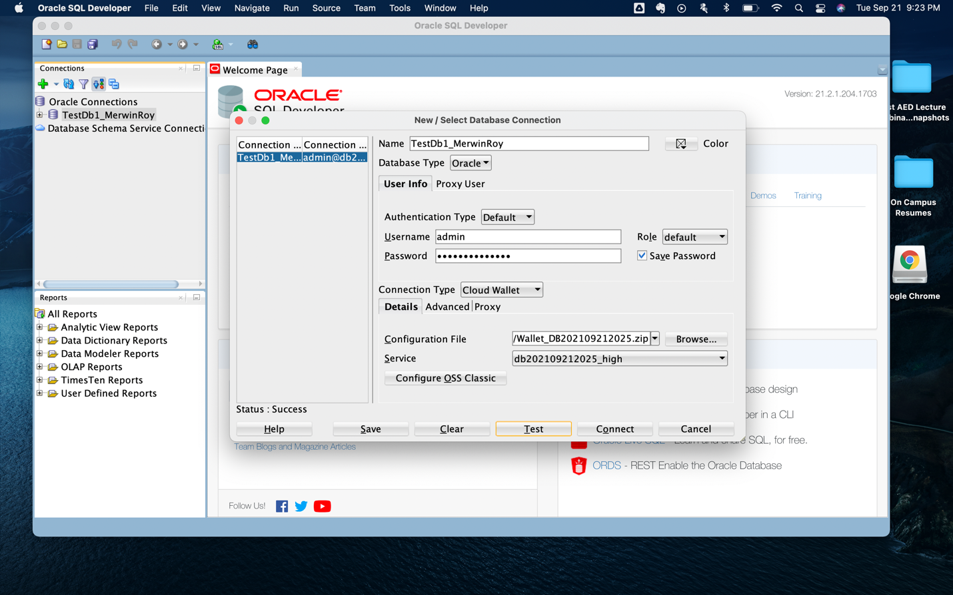

**Q2. What are metadata?**

**Ans:** Metadata is data about data. In a database, metadata provides basic information about the data stored in it which includes set of relationships that a data forms within the database as well as its characteristics.

Metadata can not only help describe the schema that is being implemented, but also any piece of information that can help identify, summarize or analyze data or record stored in a particular database. The type of data stored, its constraints, the values stored for each record, are some examples of metadata that can ensure that the data stored is as descriptive as possible.

**Q3. Use examples to compare and contrast unstructured and structured data. Which type is more prevalent in a typical business environment?**

**Ans:** Unstructured data is the type of data that is fetched in its raw, original form and since such data is unprocessed and unorganized, it is not often used in a typical business scenario since it is difficult to utilize and implement unstructured data for an average user due to its complexity.

Structured data on the other hand is derived from unstructured data and is processed to that it can be stored, analyzed, implemented or presented accordingly in a typical business environment. It is much more simplified, defined and easy to identify than unstructured data.

For example, in an inventory database management system which can be used in a business environment, price of a product can be used for analysis and computation if it is processed and formatted properly (in this case, in numeric format). However, in an unstructured form, if the format of the price is not defined once it has been fetched and if it is stored in a textual format, then no computational operations can be implemented. Hence unstructured data does not provide an organization with the flexibility to use data to its potential. Therefore, structured data is more prevalent for use in such cases.

**Q4. Why Database design is important?**

**Ans:** Database Design is an important aspect in creating and managing database management systems. It is imperative since it is a stage where the structure of the database is defined based on its use, for which certain business requirements are to be fulfilled while setting constraints and addressing as well as mitigating complexities that arise from managing data in the database.

As the performance of a database system is tied to its structure and design, a quality database design can be perceived as the foundation of an effective database management system that can yield desired results to a business for which data is an asset. This can help make the data stored in the database as descriptive as possible, which can help an organization to properly assess, identify, present or evaluate their asset.

However without a proper database design, even a good database management system can fail to deliver up to its expectations, issues and flaws may be difficult to trace which can be detrimental to an organization’s operational capabilities.

Therefore, a planned approach to the design phase will simplify the subsequent process of setting up and managing a database where flaws and issues can be addressed with relative ease and complexities can be mitigated.